# Ex.No- 10

**Aim:**

# K Nearest Neighbours

To implement K-Nearest Neighbors machine learning algorithm.

# Description:

1. Import KNeighbors Classifier through sklearn
2. Provide the necessary dataset through DataFrames
3. Finally we can obtain the KNN output through matplotlib as graph

# Program:

import pandas as pd

import matplotlib.pyplot as plt

from sklearn.neighbors import KNeighborsClassifier file_path ="Book 8.csv"

df = pd.read_csv(file_path) print("Original DataFrame:\n",df) x = df['x'].tolist()

y = df['y'].tolist()

classes = df['classes'].tolist() data = list(zip(x, y))

knn = KNeighborsClassifier(n_neighbors=1) knn.fit(data, classes)

new_x = 8

new_y = 21

new_point = [(new_x, new_y)] prediction = knn.predict(new_point)

plt.scatter(x + [new_x], y + [new_y], c=classes + [prediction[0]]) plt.text(x=new_x-1.7, y=new_y-0.7, s=f"new point, class: {prediction[0]}") plt.show()

# Output:

OriginalDataFrame x y classes

|  |  |
| --- | --- |
| 0 4 21 | 0 |
| 1 5 19 | 0 |
| 2 10 17 | 0 |
| 3 3 21 | 1 |
| 4 11 25 | 0 |
| 5 4 16 | 1 |
| 6 14 22 | 1 |
| 7 10 21 | 0 |
| 8 12 21 | 1 |
| 9 8 24 | 1 |

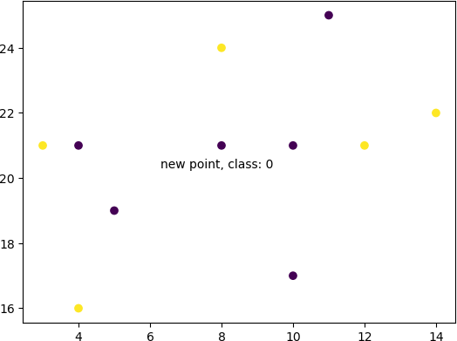

# Result:

The programs were run successfully